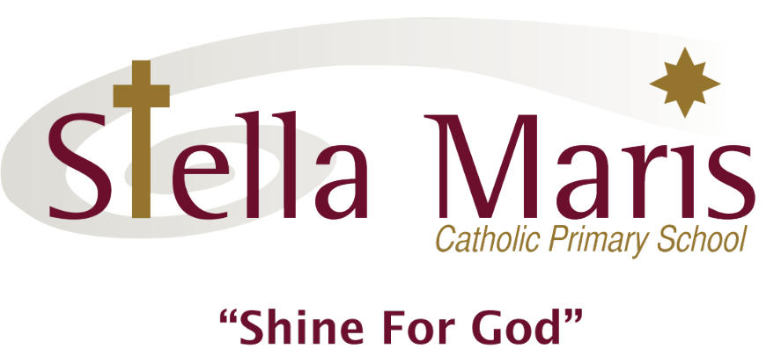

Dear Parents

I am looking forward to meeting you and getting to know your lovely children. I thought it would be a good idea to tell you a little about myself before we meet officially at the school picnic on the 28th February.

This will be my thirteenth year at Stella Maris. I began my teaching at Stella Maris by spending one day a week in a new entrant classroom. I enjoyed it so much that I decided to continue my career at Stella Maris. The following year I taught a year 5/6 class for three days a week and I have been teaching fulltime ever since then. I love teaching and I am especially passionate about Catholic education.

Prior to coming to New Zealand, I was living in South Africa with my husband and our two girls. I taught in primary schools there for ten years before moving out here. We decided to immigrate because of the rising crime rate in S.A. and because we wanted to give our daughters the chance to experience all the opportunities that New Zealand has to offer. I have been here for eighteen years now and have never looked back.

The children’s Home Learning Diaries and green plastic display books need to come to school everyday. I will collect and check them at the end of each week and they will remain at school in readiness for Monday morning. The Home Learning Diaries are also a useful tool for communication between school and home. Alternatively, I will include my e-mail address below.

The beginning of a new year is always such an exciting time filled with fresh possibilities. I look forward to helping your children discover new talents and set themselves goals for 2020. I hope to work closely with you to help make this a very productive and enjoyable year for the children. Please feel free to pop in and have a chat if you have any concerns or queries. I am usually at school quite early in the mornings. Alternatively, you could make an appointment if you needed more time.

God bless you all.

Michelle Kleingeld (Classroom Teacher in St Peter).

e-mail :-michelle@stellamaris.school.nz

